**Supplementary Data**

**A high fat/cholesterol diet recapitulates some Alzheimer’s disease-like features in mice: focus on hippocampal mitochondrial dysfunction**

Gianni **Mancini**.1, Candida **Dias**2,3, Catia F. **Lourenço2**,3, Joao **Laranjinha2**,3, Andreza **de Bem**1, 4 *, Ana **Ledo**2,3, *

1 Departamento de Bioquímica, Universidade Federal de Santa Catarina, Florianópolis, Brazil

2 Center for Neuroscience and Cell Biology, University of Coimbra, Coimbra, Portugal

3 Faculty of Pharmacy, University of Coimbra, Coimbra, Portugal

4 Department of Physiological Sciences, Institute of Biological Sciences, University of Brasília, Brasília, Brazil.

**Contents:**

**Supplementary Table I –**Composition of diets.

**Figure S1 –** Supplementary data obtained from activity in open field apparatus.

**Figure S2** – Data for Y-maze Training Trial.

**Figure S3 -** Effect of a high fat/cholesterol diet on cellular components of the neurovascular unit in CA3 subregion of the hippocampus of NTg and 3xTg-AD mice**.**

**Supplementary Table I –** Detailed Composition of the control and high fat/cholesterol diets used in the present study

|  |  |  |
| --- | --- | --- |
|  | Control Diet | High Fat/Cholesterol Diet |
| Macronutrients (w/w %) | | |
| Protein | *20.3* | *20* |
| Fat | *4.0* | *19.7* |
| Carbohydrate | *67.0* | *48.5* |
|  | **Energy** (kcal g-1) |  |
|  | *3.84* | *4.51* |
| Ingredients (g per kg of chow) | | |
| Casein | *200* | *200* |
| L-cystine | *3* | *3* |
| Corn Starch | *150* | *270* |
| Maltodextrin 10 | *0* | *113* |
| Sucrose | *500* | *100* |
| Cellulose | *50* | *50* |
| Corn Oil | *50* | *0* |
| Soybean Oil | *0* | *200* |
| Mineral Mix S10026B | *35* | *50* |
| Vitamin Mix V10001 | *10* | *10* |
| Choline bitartrate | *2* | *2* |
| Cholic Acid, Sodium Salt | *0* | *5* |
| Cholesterol | *0 (0%)* | *12.5 (1.25%)* |



**Figure S1 –** Representative traces obtained for each animal group in the open field apparatus (A). Quantification of the number of rearings (B) and immobilization time (C) observed during the 10 min period spent in the open field apparatus.

**.**

**Figure S2 -** Quantification of % of time spent in each arm (A) and number of arm entries (B) observed in the training trial of the Y-maze. S: starting arm; O: other arm; N: novel arm.

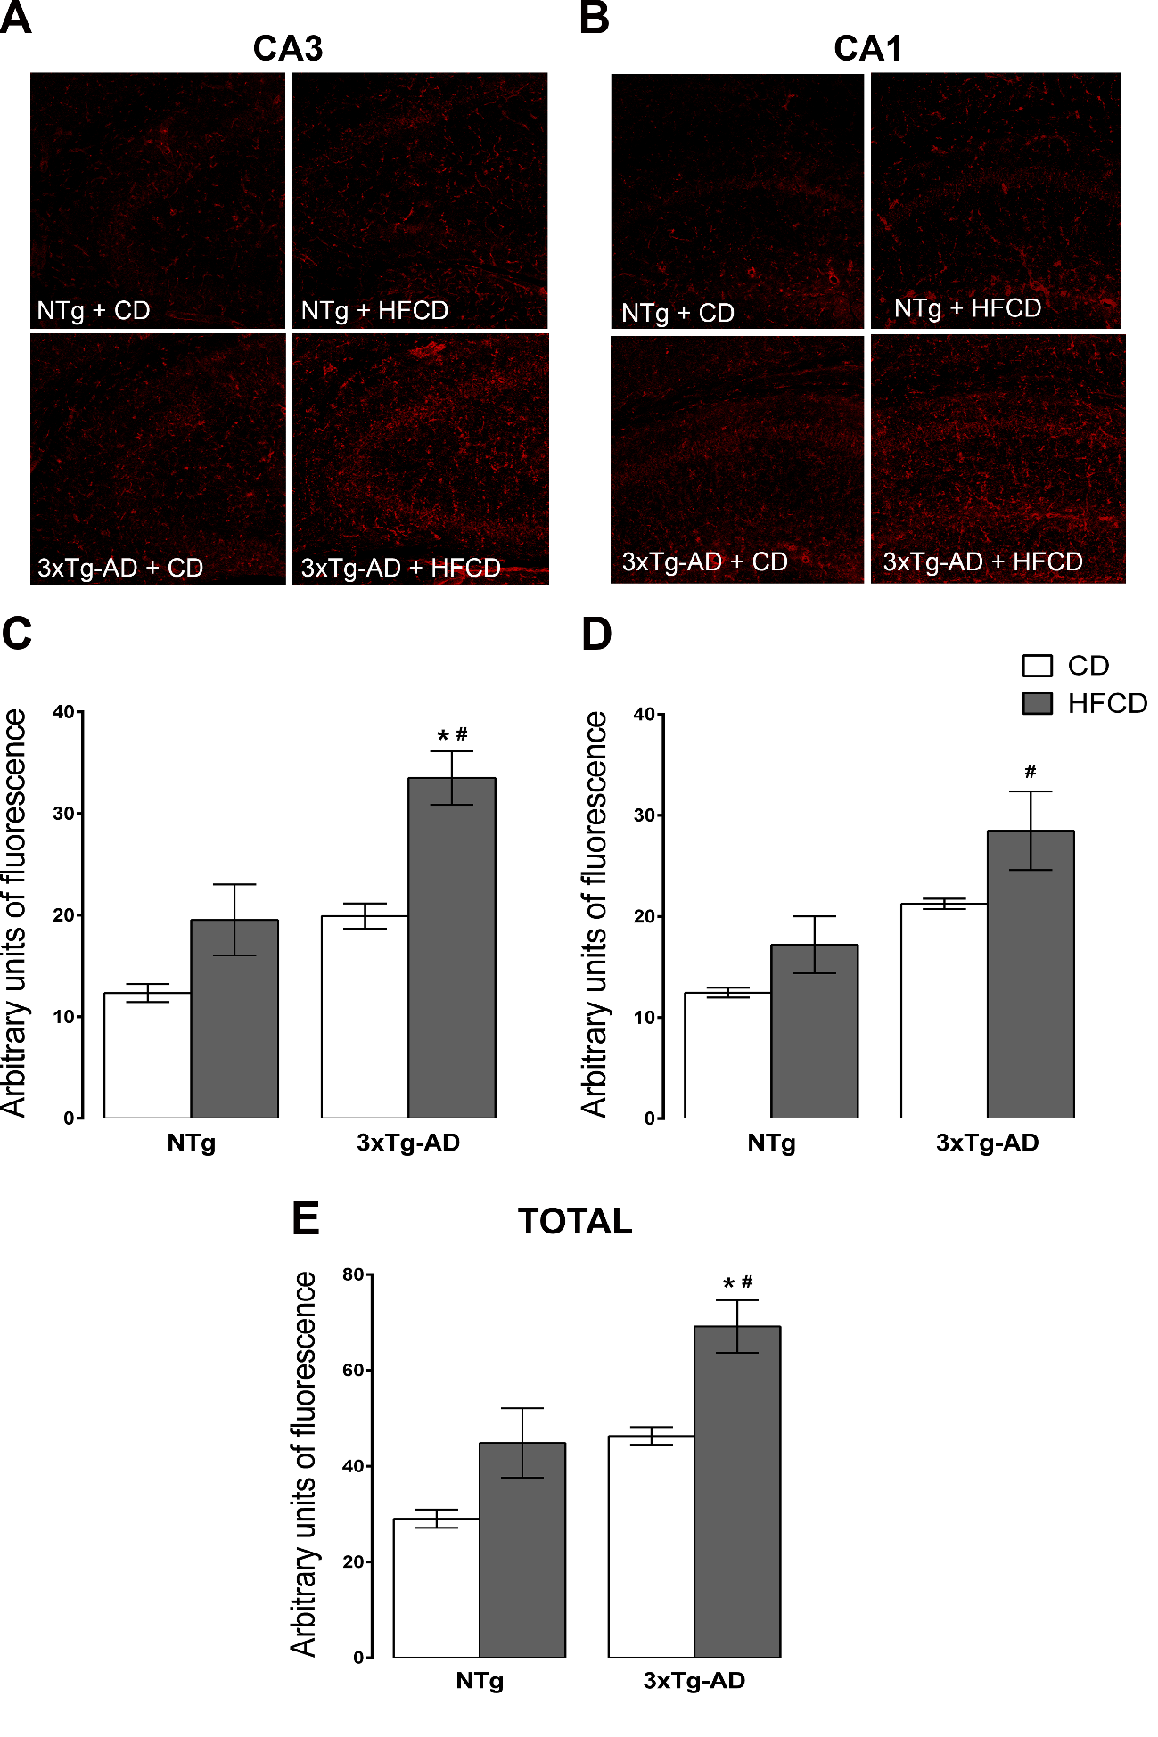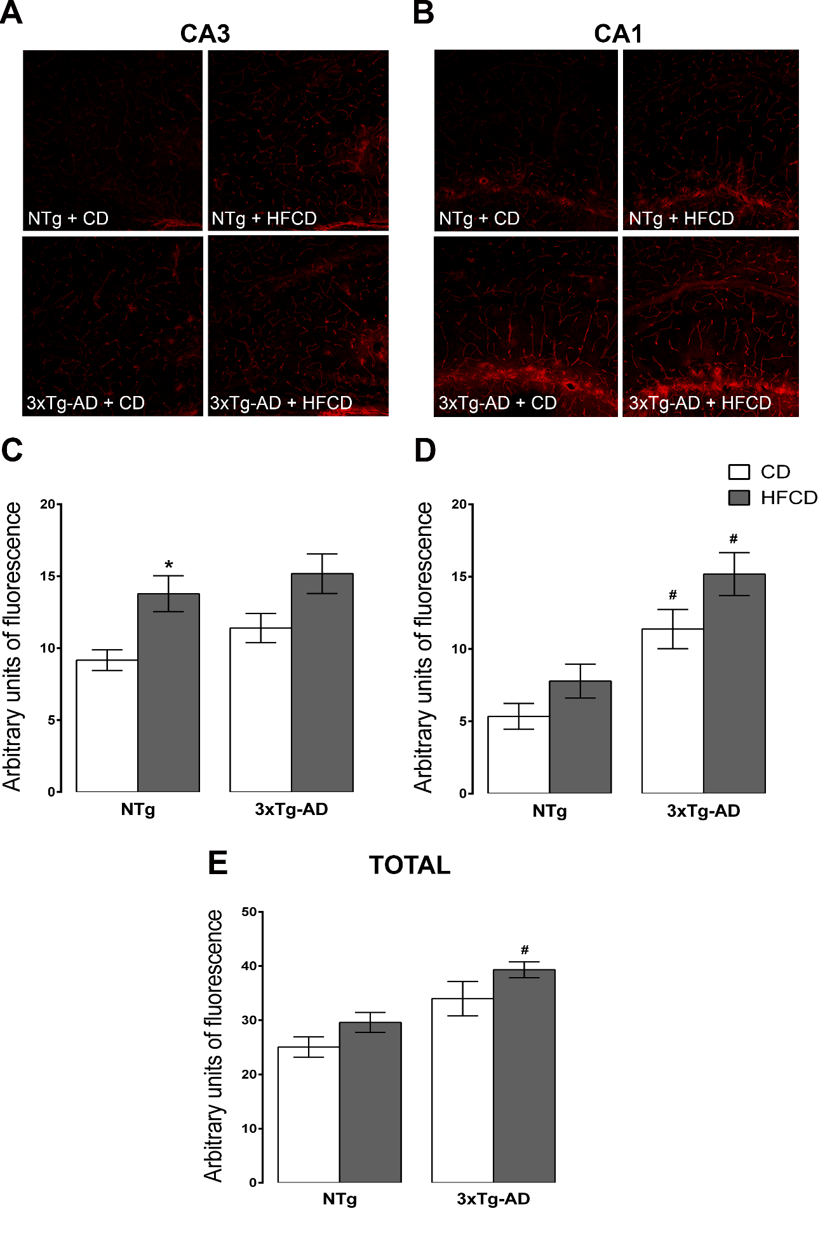

**A**

**B**

**C**

**D**

**Figure S3 - Effect of a high fat/cholesterol diet on cellular components of the neurovascular unit in CA3 subregion of the hippocampus of NTg and 3xTg-AD mice.**

A - Representative images of AQP-4 immunostaining in the CA3 subregion of the hippocampus; B - Quantification of AQP-4 immunofluorescence; C – Representative micrographs of Tomato Lectin immunostaining in the CA3 subregion of the hippocampus; D – Quantification of Tomato Lectin immunofluorescence. Scale bars, 100 µm. *P < 0.05 and **P < 0.01 when determining the effect of genotype for the same diet (2-way ANOVA followed by Bonferroni).